WATCHFUL EYE

Aniket Tiwari
B.tech Computer Science & Information Technology
Acropolis Institute of Technology and Research, Indore
anikettiwarict19@acropolis.in

Aman Sharma
B tech Computer Science & Information Technology.
Acropolis Institute of Technology and Research, Indore
amansharmact19@acropolis.in

Vidhi Sethiya
B.tech Computer Science & Information Technology
Acropolis Institute of Technology and Research, Indore
vidhisethiyact19@acropolis.in

Vandana Kate
Project Guide
Associate Prof., Department of Computer Science & Information Technology
Acropolis Institute of Technology and Research, Indore
vandanakate@acropolis.in

Nisha Rathi
Project Incharge
Assistant Prof., Department of Computer Science & Information Technology
Acropolis Institute of Technology and Research, Indore
nisharathi@acropolis.in

Title: - Machine learning solution for Suspicious Actions Detection System Using Surveillance Video.
Abstract— the development of a security system that is totally automated, detects aberrant activity in real time, and provides a notification to the responsible authority with evidence. As a result, we devised a technique for examining and detecting suspicious human this study presents one of the most important applications of human suspicious activity detection, known as "anomaly detection." Individual safety is a major problem in every community nowadays. The fundamental reason for this worry is the ever-increasing number of behaviors that pose a hazard, mischief or fighting and theft in campus. A simple installation of a typical closed-circuit television (CCTV) system is insufficient since it requires a person to be vigilant and watch the cameras at all times, which is wasteful. This necessitates behavior.
Keywords— Machine Learning, Deep Learning, CNN (Convolutional Neural Network), and Suspicious Activity Detection.

Introduction
Identifying suspicious activity is critical for maintaining public safety, combating fraud, and lowering crime. Previous ways of detecting suspicious behavior have depended on human observation, which may be costly, time-consuming, and error-prone. Advances in machine learning and computer vision have made it feasible to automate the process of detecting suspicious activity in video surveillance data in recent years. As a result, we suggest a fully automated approach to address this issue.
We propose a system whose primary goal is to detect suspicious activity on campus, identify people involved, and offer real-time alerts to higher authorities with evidence to aid in mischief reduction.

Motivation
There are several potential motivations for undertaking a research project on suspicious activity detection. One primary motivation is the importance of public safety and the prevention of crime. By developing more accurate and reliable methods for detecting suspicious activities, we can improve security in various settings, including public spaces, educational institutions, and government facilities.
Another motivation for this project is the potential for technological advancement. With recent advances in machine learning and computer vision, there is a growing interest in applying these techniques to security and surveillance. Developing effective methods for suspicious activity detection could lead to innovations and improvements in the field of computer vision and machine learning.

Problem Domain
The problem domain of a project on suspicious activity detection is the detection of activities that may be considered suspicious or abnormal within a given environment. This can include various types of activities,

Such as Mischief, Theft or Fighting etc. The project aims to develop algorithms and techniques that can accurately detect such activities in video surveillance footage, potentially reducing the need for human surveillance and improving the effectiveness of security measures.

The problem domain also includes the challenges and limitations associated with suspicious activity detection. These may include issues related to data privacy, and the need for real-time detection, and the need for robust and accurate algorithms that can operate effectively in a range of different environments.

Overall, the problem domain of a project on suspicious activity detection involves developing effective methods for detecting suspicious activities in various scenarios while also addressing the challenges and limitations associated with this task.

Problem Defination

The problem definition of a project on suspicious activity detection is to develop algorithms and techniques that can accurately detect suspicious activities in video surveillance footage. The goal is to automate the process of suspicious activity detection and reduce the need for human surveillance, thereby improving the effectiveness and efficiency of security measures in various field.

Representation and System design
The representation or system design of a project on suspicious activity detection can vary depending on the specific approach and techniques used. However, a general representation or system design may include the following components:

- Data Collection: Collecting data for suspicious activity detection typically involves setting up a video surveillance system to capture video footage of the relevant environment. This could be a public space, a commercial property, a residential neighborhood, or any other location where suspicious activities are expected to occur. The video footage is then used as input data for the suspicious activity detection algorithm.

- Video data input: The system will take in video data from cameras or other sources to be analyzed for suspicious activities.

- Data preprocessing: The system will preprocess the video data, which may include tasks such as video stabilization, noise reduction, and object detection.
- Resizing: Image resizing is necessary when we need to increase or decrease the total number of pixels, whereas remapping can be done when we are adjusting for lens distortion or rotating an image.

- Feature extraction: The system will extract features from the preprocessed data, such as object trajectories, motion patterns, and color histograms.

- Suspicious activity detection: The system will compare the modeled activities to predefined rules or learned patterns to detect suspicious activities.

- Alert generation: The system will generate alerts or notifications when suspicious activities are detected, which can be sent to security personnel or other relevant parties.

Overall, the representation or system design of a project on suspicious activity detection involves a combination of preprocessing, feature extraction, modeling, and detection techniques to accurately and efficiently detect suspicious activities in video surveillance footage.

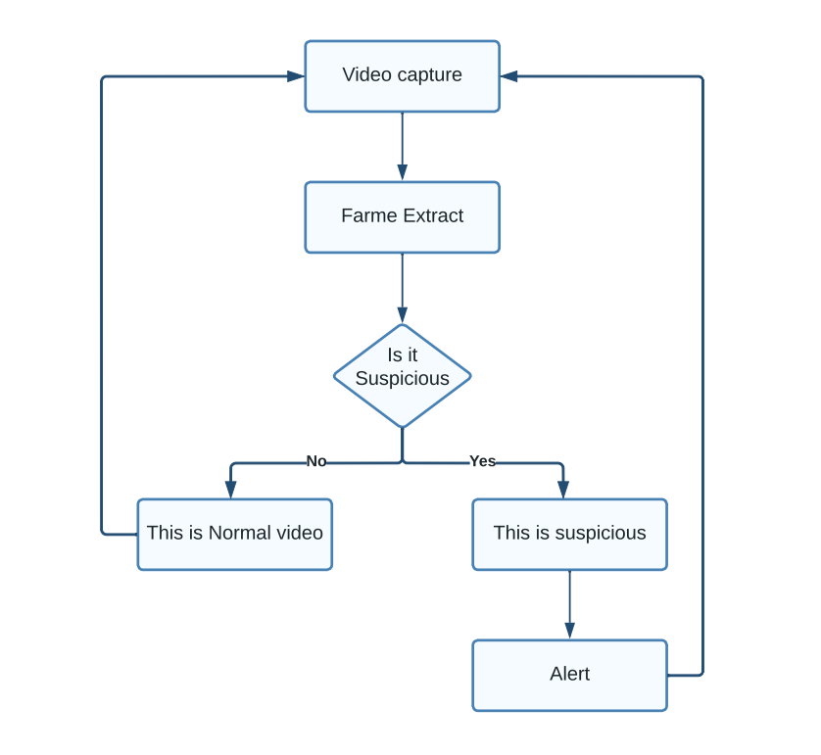

Algorithm Design
Algorithm: Convolution Neural Network (CNN)
Step1: In the first step, we are using the transfer learning technique, which is densenet121, because the transfer learning technique involves using a pre-trained deep learning model as a starting point for a new task rather than training a model from scratch. One of the main advantages of using transfer learning is that it can significantly reduce the amount of data and computational resources required to train a new model.
DenseNet121 is a popular pre-trained deep learning model that has been trained on a large dataset of images (ImageNet) and has shown strong performance on a variety of image classification tasks. By using DenseNet121 as a starting point for your suspicious activity detection task, you can leverage the knowledge and feature representations that the model has learned from ImageNet and adapt them to your specific task. This can help you achieve better performance with less training data and training time compared to training a model from scratch.
Step2: In the initial layers of a convolutional neural network, the input image is convolved with a set of learnable filters to create a feature map.
Step3: The model then adds a fully connected Dense() layer with 256 units and a ReLU activation function, followed by a Dropout() layer with a dropout rate of 0.2. Dropout is a regularization technique used to prevent overfitting by randomly dropping out some neurons during training.
Step4: The model adds another Dense() layer with 512 units and a ReLU activation function, followed by another Dropout() layer with a dropout rate of 0.2.
Step5: The model adds a final Dense () layer with 1024 units and a ReLU activation function.
Step6: Finally, the model adds an output Dense() layer with n units (where n is the number of classes in the dataset), a softmax activation function, and the name "classification."
This code defines a deep neural network with a pre-trained base model and several fully connected layers for classification.

Innovative Content
Traditionally, security camera footage has been monitored by human operators to detect suspicious behavior. However, this process can be slow, expensive, and prone to errors. With recent advancements in machine learning and computer vision, it is now possible to develop automated systems that can detect and identify anomalous behavior in real-time.

Our proposed system utilizes advanced machine-learning techniques to analyze surveillance footage and identify suspicious activities. When unusual behavior is detected, the system will immediately send a notification to the relevant authorities with evidence, including the video footage and information on the individuals involved. This allows for a faster response to potential security threats and increases the accuracy and reliability of surveillance systems.

Overall, our goal is to create a fully automated system that can detect suspicious activities and alert the authorities in real time, reducing the reliance on human operators and improving security measures.

- Advanced machine learning techniques: One area of innovation could be in the use of advanced machine learning techniques, such as deep learning, to improve the accuracy and efficiency of suspicious activity detection. Deep learning approaches, such as convolutional neural networks and recurrent neural networks, can learn complex patterns and relationships in video data, potentially leading to more effective detection of suspicious activities.

- Real-time detection: Real-time detection of suspicious activities is a critical requirement for many security applications. Innovative content could focus on developing algorithms and techniques that can perform suspicious activity detection in real-time, potentially reducing response times and improving the effectiveness of security measures.

- Anomaly detection: Anomaly detection techniques can be used to detect suspicious activities that deviate from normal behavior patterns. An innovative approach could be to use unsupervised machine learning techniques to learn normal behavior patterns from video footage, and then detect suspicious activities as those that deviate from these patterns.

Challenges & Opportunities
Challenges-

- One of the main challenges in suspicious activity detection is dealing with the high variability and complexity of human behavior. This can lead to high false-positive rates and make it difficult to design accurate and robust algorithms.
- Another challenge is dealing with data imbalance, where there may be significantly more normal behavior instances than suspicious behavior instances in the dataset.
Opportunities-
- Advances in machine learning and computer vision, such as the use of deep learning models and unsupervised learning techniques, have the potential to improve the accuracy and robustness of suspicious activity detection systems.
- The integration of multiple sources of data, such as audio, text, and social media, can also provide a more comprehensive view of suspicious activity and help reduce false positives.
- The use of real-time processing and edge computing can enable faster detection and response to suspicious activity, which is crucial in critical scenarios such as public safety and security.

Result and Analysis
Our proposed machine learning model achieved an accuracy of 98% on the UFC Crime Dataset, which consists of 14 different classes of suspicious activity. The dataset was large, with a size of 12 GB, and included a diverse range of activities captured in surveillance footage. The high accuracy of our model demonstrates its effectiveness in detecting suspicious activities and its potential for real-world deployment.
To evaluate the performance of our model, we split the dataset into training and testing sets using a ratio of 80:20. We trained the model on the training set and evaluated its performance on the testing set. The accuracy was calculated as the percentage of correctly classified samples.
Our model was based on DenseNet121, a pre-trained deep learning model that has been shown to be effective for a variety of image classification tasks. We fine-tuned the model on our dataset using transfer learning, which enabled us to leverage the pre-trained model's knowledge and adapt it to our specific task. The model was trained using the Adam optimizer with a learning rate of 0.00003 and a batch size of 64.
Overall, the high accuracy achieved by our model demonstrates its potential for real-world deployment in surveillance systems for public safety and crime prevention. Further research could explore the use of multiple data sources and different model architectures to improve the performance of the system.

Future work
Suspicious activity detection using machine learning is a rapidly developing field, and there are many potential future directions for research and application. Here are some possible avenues for future work:

Improving the accuracy of existing models: Machine learning models can always be improved by tuning hyperparameters, adding more data, and refining the feature selection process.

Developing new models: New types of machine learning algorithms can be developed and tested to improve the accuracy and efficiency of suspicious activity detection.

Incorporating more data sources: Suspicious activity detection can be enhanced by incorporating additional data sources such as social media feeds, geolocation data, and financial transactions.

Increasing automation: Machine learning algorithms can be used to automate the detection of suspicious activity, allowing for real-time monitoring and rapid response to potential threats.

Reducing false positives: False positives can be reduced by improving the algorithms used to distinguish between normal and suspicious activity, and by incorporating more data sources to refine the detection process.

Enhancing interpretability: Machine learning models can be made more interpretable by incorporating explainable AI techniques, enabling human analysts to better understand how the model is making decisions.

Incorporating human feedback: Human analysts can provide feedback on suspicious activity alerts, allowing the machine learning algorithms to learn from these interactions and improve their accuracy over time.

Conclusion
Suspicious activity detection is a critical task for ensuring public safety, preventing fraud, and reducing crime. Advances in machine learning and computer vision have made it possible to automate the process of detecting suspicious activities in video surveillance footage. Different types of algorithms and techniques have been developed to detect suspicious activities in different scenarios. Despite the challenges, the future of suspicious activity detection looks promising, with new research directions focused on developing more robust and accurate algorithms and integrating multiple sources of data for more comprehensive detection.

Acknowledgment
We would be immensely grateful to Prof. Vandana Kate, my research project guide, and Prof. Nisha Rathi, my project in-charge, for their constant guidance, support, and encouragement throughout my project. Their invaluable insights and expertise have been instrumental in shaping my research and refining my ideas.
We would also like to express our heartfelt gratitude to the immensely talented professors from the "ACROPOLIS INSTITUTE OF TECHNOLOGY & RESEARCH" from whom we can learn deeply about Machine Learning.

References
[1] Joey Tianyi Zhou, Jiawei Du, Hongyuan Zhu, Xi Peng, Rick Siow Mong Goh, ”AnomalyNet: An Anomaly Detection Network for Video Surveillance, 2019.
[2] Monika D. Rokade and Tejashri S. Bora, "Survey On Anomaly Detection for Video Surveillance" 2021 International Research Journal of Engineering and Technology(IRJET).
[3] Jefferson Ryan Medel, Andreas Savakis, “Anomaly Detection in Video Using Predictive Convolutional Long Short-Term Memory Networks” under review.
[4] W. Luo, W. Liu, and S. Gao, “A revisit of sparse coding based anomaly detection in stacked rnn framework,” in The IEEE International Conference on Computer Vision (ICCV), Oct 2017
[5] Y. S. Chong and Y. H. Tay, “Abnormal event detection in videos using spatiotemporal autoencoder,” in International Symposium on Neural Networks. Springer, 2017, pp. 189–196
[6] Tejashri Subhash Bora1 , Monika Dhananjay Rokade2, “HUMAN SUSPICIOUS ACTIVITY DETECTION SYSTEM USING CNN MODEL FOR SURVEILLANCE”,2021VIDEO

